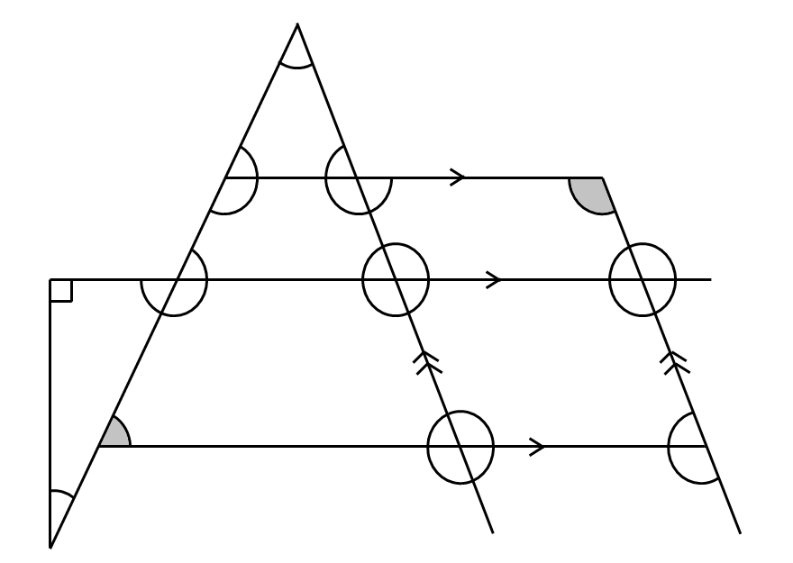
Diagram not
accurately drawn.
Diagram not
accurately drawn.

Name………………………………………………… Time…………………………………………

Name………………………………………………… Time…………………………………………

